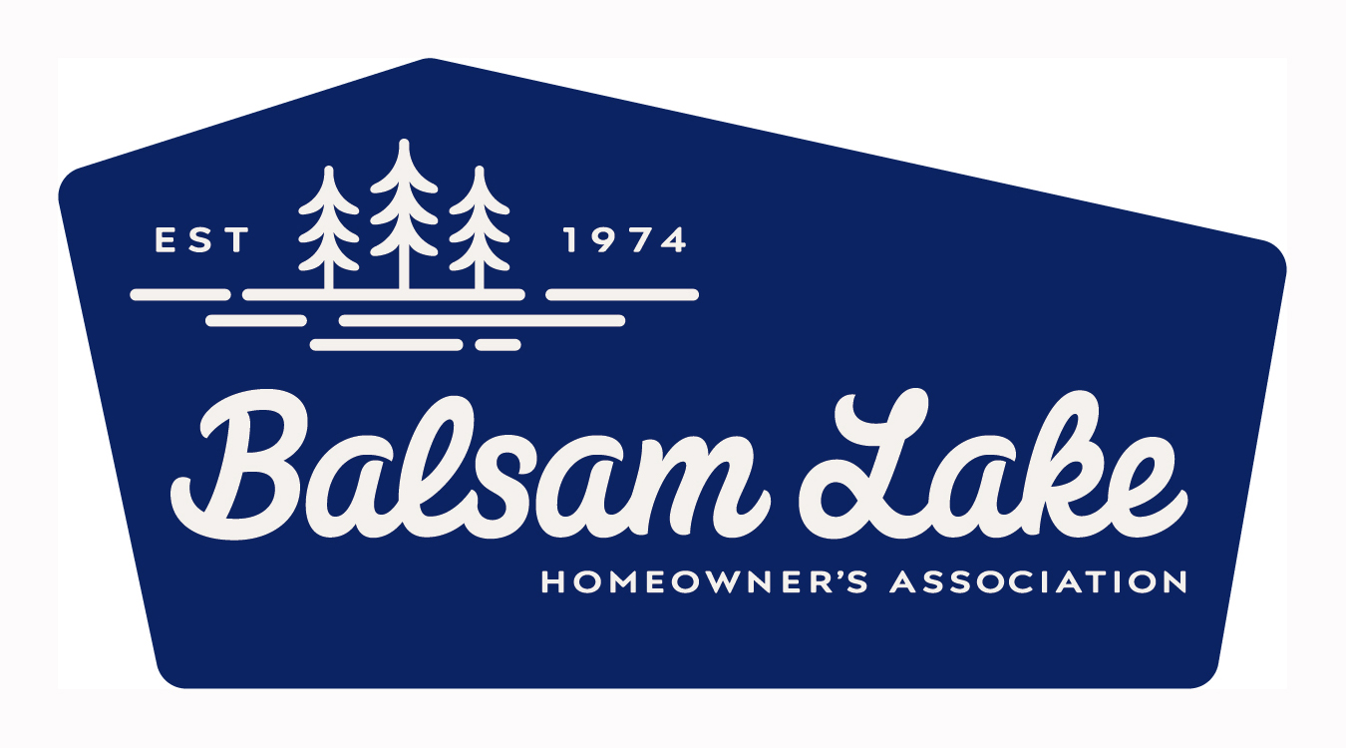
Balsam Lake Homeowners’ Association
2024 MEMBERSHIP FORM
It’s time to join or renew your BLHA Membership. While our name is Balsam Lake Homeowners’ Association, anyone is welcome to join. If your family members are interested in receiving our mailings, simply share a copy of this form with them to complete and return with their dues. Our mission is to promote the enjoyment of Balsam Lake through safety, communications, and special events.

Name:
Last First Spouse/Partner

YEAR-ROUND MAILING ADDRESS, Include P.O. Box # if used. All mailings go to this address.
Street:
City: State: Zip:
Phone:

LAKE ADDRESS:
Street:
City: State: Zip:
Phone:

Primary Email:
Secondary Email:
Please include your e-mail address and a secondary one if you want others to receive the mailings and e-mail blasts. We
do not give, sell, or share this list.

2024 MEMBERSHIP DUES ENCLOSED: $ 50.00
Membership cards are sent to you when completed forms and dues are received.

FIREWORKS – ADDITIONAL CONTRIBUTION: $________________
The Balsam Lake Freedom Fest Fireworks are made possible through your membership dues, along with contributions
from The Village of Balsam Lake and local businesses. Individual membership funds make our fireworks the most spectacular
in the area.

BOAT PATROL – ADDITIONAL CONTRIBUTION: $________________
The BLHA wants everyone to enjoy the lake and follow the local laws that keep our lake safe and enjoyable for all to use. We provide a boat and resources for a boat patrol that benefits all who use and enjoy the lake. Please consider a donation to keep this very important feature of our lake in good working condition.
.

Membership Forms Due February 15, 2024 TOTAL ENCLOSED: $________________

The purpose of the association shall be to enhance the quality of life and the enjoyment of Balsam Lake for Homeowners and others by promoting water safety, protecting the environment, and preserving the ecology through our actions, communications and support of the community with special events.

